L ARCH 4XX | Aut 2017 Department of Landscape Architecture
Landscape Architecture/Architecture in Rome Program UW College of Built Environments

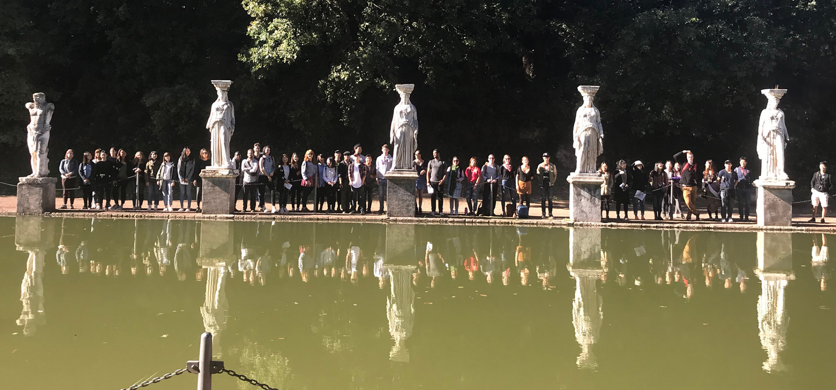
Course Name

Hadrian’s Villa

Course Syllabus

1. Course Description:
Faculty: name
[pronouns]
Office hours: xx
Email: xx@uw.edu

Schedule: MWF 9:30-11:00 am
Location: xx
Course website:

Course Structure:
text

Readings + Texts:
text

Materials + Supplies:
Students will require the following equipment and materials. Materials can be purchased at xx.
- Xx

Course Content:
text

Learning Objectives:
General description
The course will engage students in critical thinking and reflection. More specifically, this course will help you to:
- Objective 1
- Objective 2, etc

2. Course Assessment + Expectations:

Assignments + Assessments:
The assignments for the quarter will be:
- Assignment 1 (include name, brief description, %age of grade, due dates
- etc

Grading System:
This course emphasizes curiosity, reflection, experimentation and transformation. Evaluations are based upon completion of assigned work and demonstrated engagement with the materials, ideas, and sites. Grades are assigned in accordance with the UW Standard Grading System and the Department of Landscape Architecture grading guidelines.

Breakdown of grades
XX 25%
etc

Grading System:
define/describe grading system

Schedule, Readings + Due Dates

Provide schedule

3. Course Policies

Academic Misconduct:
The University takes academic integrity very seriously. Behaving with integrity is part of our responsibility to our shared learning community. If you’re uncertain about if something is academic misconduct, ask me. I am willing to discuss questions you might have.

Acts of academic misconduct may include but are not limited to:
- Plagiarism (representing the work of others as your own without giving appropriate credit to the original author(s))
- Cheating (working collaboratively on quizzes/exams and discussion submissions, sharing answers and previewing quizzes/exams)
- Unauthorized collaboration (working with each other on assignments)
Concerns about these or other behaviors prohibited by the Student Conduct Code will be referred for investigation and adjudication by CBE’s Associate Dean for Academic Affairs.

Students found to have engaged in academic misconduct may receive a zero on the assignment or be required to redo and resubmit the assignment.
.

Access + Accommodation:
Your experience in this class is important to me. If you have already established accommodations with Disability Resources for Students (DRS), please communicate your approved accommodations to me at your earliest convenience so we can discuss your needs in this course.

If you have not yet established services through DRS, but have a temporary health condition or permanent disability that requires accommodations (conditions include but not limited to; mental health, attention-related, learning, vision, hearing, physical or health impacts), you are welcome to contact DRS at 206-543-8924 or uwdrs@uw.edu or disability.uw.edu. DRS offers resources and coordinates reasonable accommodations for students with disabilities and/or temporary health conditions. Reasonable accommodations are established through an interactive process between you, your instructor(s) and DRS. It is the policy and practice of the University of Washington to create inclusive and accessible learning environments consistent with federal and state law.

Religious Accommodation:
Washington state law requires that UW develop a policy for accommodation of student absences or significant hardship due to reasons of faith or conscience, or for organized religious activities. The UW’s policy, including more information about how to request an accommodation, is available at Religious Accommodations Policy (https://registrar.washington.edu/staffandfaculty/religious-accommodations-policy/).

Accommodations must be requested within the first two weeks of this course using the Religious Accommodations Request form (https://registrar.washington.edu/students/religious-accommodations-request/).

Grading:
Grades will be determined by the instructor based on the stated criteria above. Grades will be available to students through the course Canvas. If a student has questions about their assessment or would like additional feedback, they should schedule a meeting with the instructor during their office hours.

Inclusivity + Respect for Everyone (Adapted from University of Denver):
In this class, we will work together to develop a learning community that is inclusive and respectful. Our diversity may be reflected by differences in race, culture, age, religion, sexual orientation, socioeconomic background, ability, and myriad other social identities and life experiences. The goal of inclusiveness, in a diverse community, encourages and appreciates expressions of different ideas, opinions, and beliefs, so that conversations and interactions that could potentially be divisive turn instead into opportunities for intellectual and personal enrichment.

A dedication to inclusiveness requires respecting what others say, their right to say it, and the thoughtful consideration of others’ communication. Both speaking up and listening are valuable tools for furthering thoughtful, enlightening dialogue. Respecting one another’s individual differences is critical in transforming a collection of diverse individuals into an inclusive, collaborative and excellent learning community. Our core commitment shapes our core expectation for behavior inside and outside of the classroom.

In this course, we will support elective gender pronoun use and self-identification. As the course includes group work and in-class discussion, it is vitally important for us to create an educational environment of inclusion and mutual respect.

It is the intention of the instructors that all course assignments and activities should be accessible to all students, including class trips. However, if a student is not able to participate in a class trip due to accessibility issues, they should discuss this with the instructor who will arrange for an alternative assignment.

Technology Protocols:
Technology devices (phones, tablets, laptops) may be used in class provided they are assisting the student in coursework (taking notes, research, etc). Technology devices should not be used for non-coursework or in ways that negatively impact the student or other students in the course. In such cases, the student will be asked to turn off and store the device until the end of the course. If this is a repeating pattern, the student will be asked to refrain from bringing the device to class.

For this course, we will use multiple forms of technology for submitting and sharing work.

Canvas
Canvas is the main hub for the course. All course content including syllabus, current schedule, class agendas, readings, and assignments is on Canvas. Links for miro assignments boards, google drive, etc. can be found on the Home Page of Canvas.

Google Drive
We will use Google Drive for sharing resources and research. The link for the course Google Drive is on the Canvas home page.

Health + Wellness:
As always, health and well-being are top priorities. Students will have different responses to events and issues inside and outside of school. Whatever you are feeling, your feelings are valid and do not require justification. If there is something that you are comfortable sharing and feel it would be helpful for me to know, please share it with me. But most importantly, please care for yourself. Remember to be kind to yourself. Now is a great time to learn and practice self-care.
Students are encouraged to access resources as needed to support your well-being through the UW Husky Health & Well-being – a portal with many different resources.
Update to date information about COVID-19 is available on the CBE website with links to UW’s information site - http://be.uw.edu/covid-19-information/

Campus Safety:
If you have any concerns for your safety or for that of others, call SafeCampus at 206-685-7233. SafeCampus is available at any time – no matter where you work or study – to anonymously discuss safety and well-being concerns for yourself or others. SafeCampus’s team of caring professionals will provide individualized support, while discussing short- and long-term solutions and connecting you with additional resources when requested. For any emergency, call 911.

Archiving + Documenting Student Studio Work:
Copies of all completed assignments should be uploaded to the course Canvas site as assignments are finished. Students are required to submit all work from the term digitally on Canvas BEFORE final grades will be distributed.

Excused Absence from Class + Medical Notes:
Students are expected to attend class and to participate in all graded activities, including class discussions, field trips, desk crits, pin-ups and reviews.. A student who is anticipating being absent from class due to a Religious Accommodation activity needs to complete the Religious Accommodations request process by the second Friday of the quarter. Students who anticipate missing class due to attendance at academic conferences or field trips, or participation in university-sponsored activities should provide a written notice to the instructor at least 1 week ahead of the absence. The instructor will discuss what will be missed with the student and determine if the course activity can be rescheduled or if there is equivalent work that can be done as an equivalent, as determined by the instructor. A student absent from class due to illness should make an appointment with the instructor to discuss what the student missed during their absence and what activity needs to be rescheduled or if there is equivalent work that can be done as an equivalent, as determined by the instructor. To protect student privacy and the integrity of the academic experience, students will not be required to provide a medical excuse note to justify an absence from class due to illness.

