
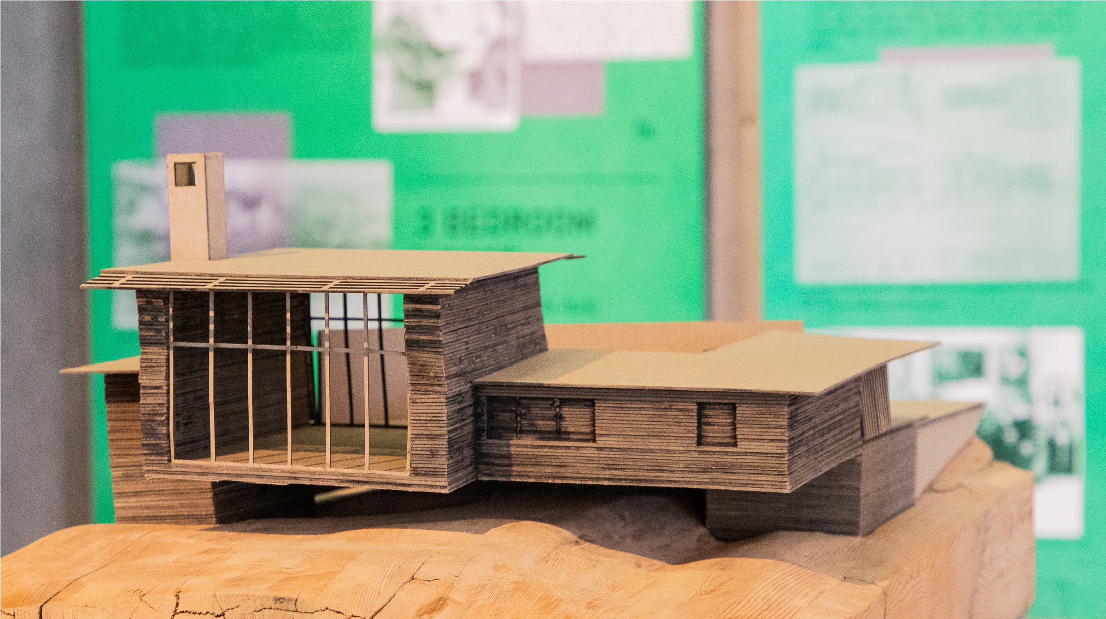

RESEARCH PRACTICE IN THE BUILT ENVIRONMENT

BE 598 C
EXPAND YOUR RESEARCH TOOLKIT THIS WINTER QUARTER WITH THIS ONE-CREDIT, GRADUATE-LEVEL SEMINAR.
Join Professor Jane Doe and guest instructors from across CBE and our industry partners for this introduction to research methodologies, technology based strategies, and online tools. We’ll also explore research practice within the built environment fields — both now and in the future.
Topics Include:
Topics Include:
> Crafting a good research question
> Library and archival research
> Literature reviews
> Familiarization with Zotero and other bibliography tools
> Qualitative v Quantitative methods, and how to choose
> Bias in data collection and interpretation
> Research in practice
> Future research practice

Enrollment Information:
Contact:

Image

INSTRUCTOR: PROF. JANE DOE
FRIDAY’S, 8–9:20 A.M. PT
(SYNCHRONOUS)
WEEKS 2–9 OF WINTER QUARTER

