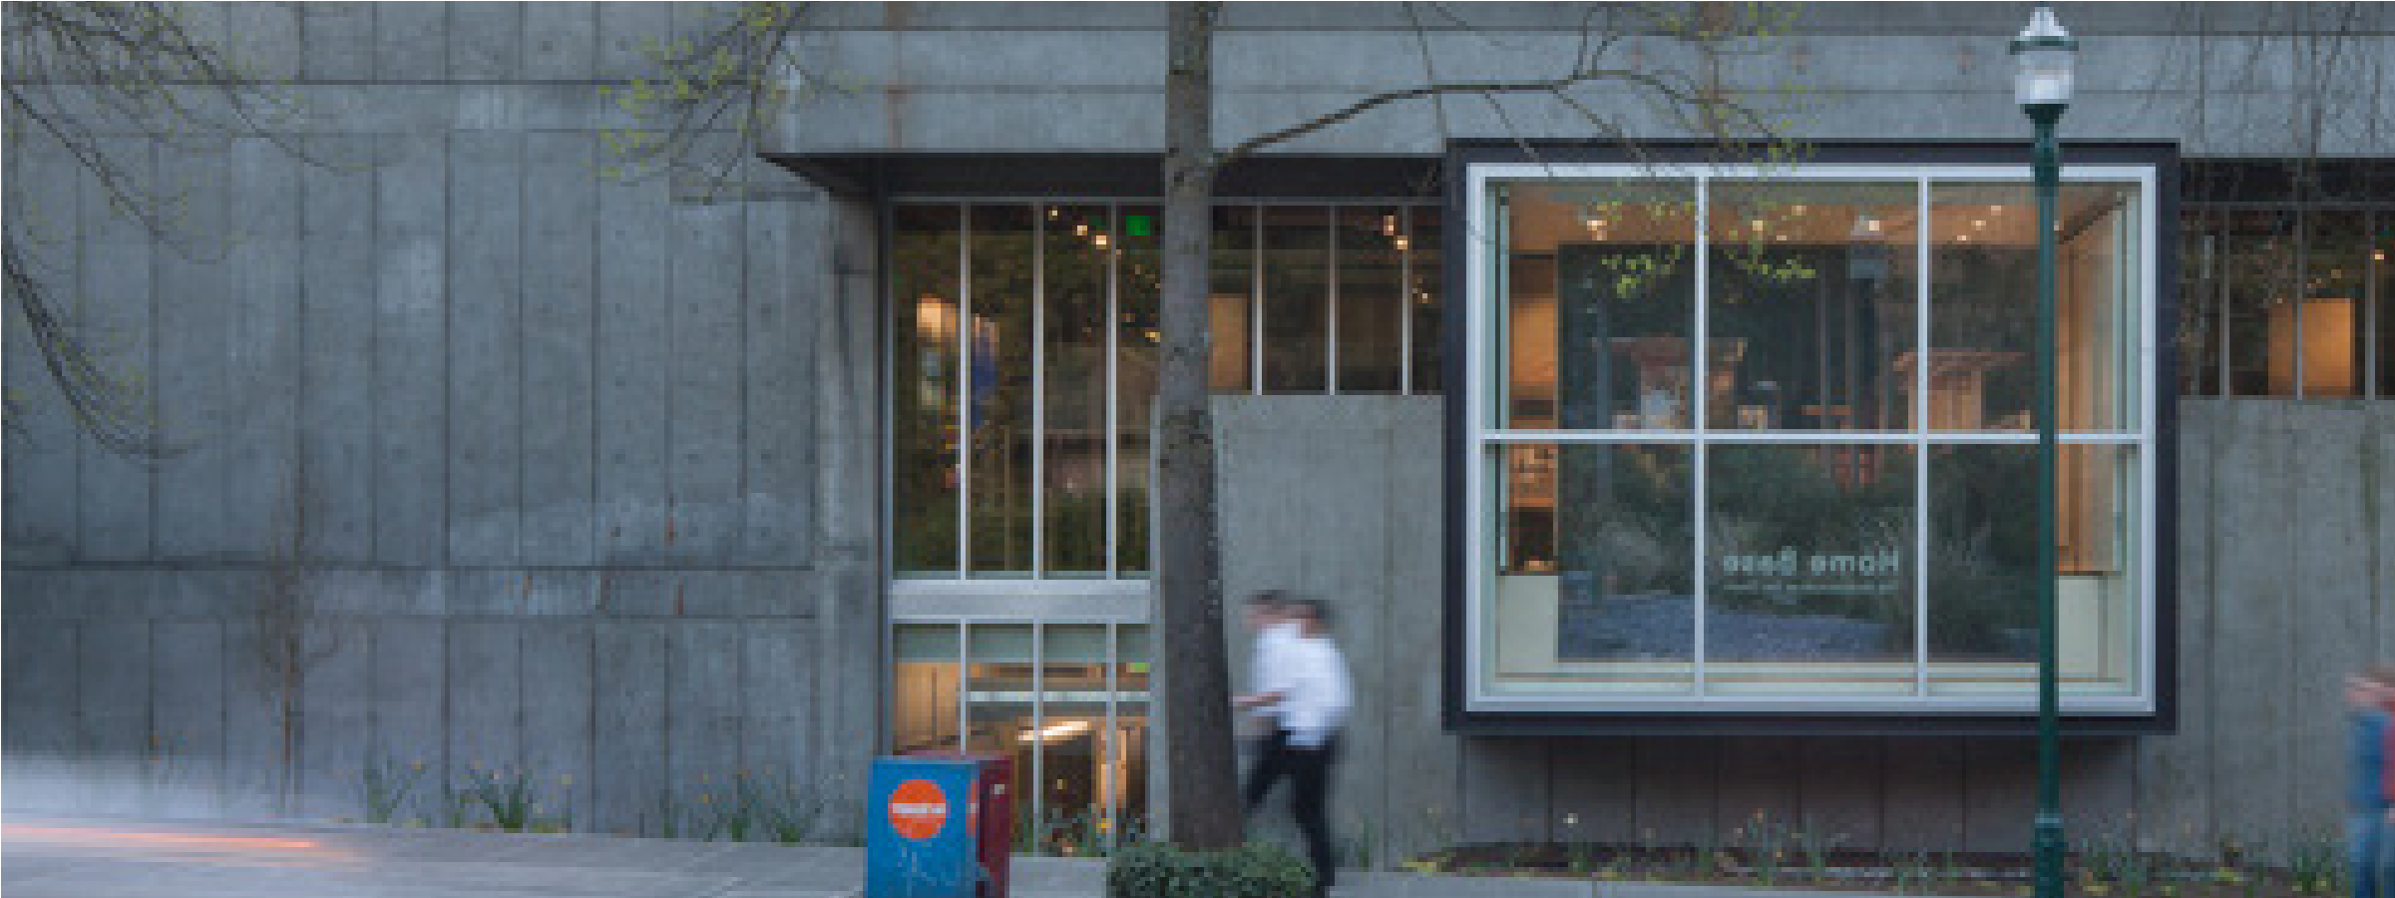


ASPIRE INTERNSHIP

COMPENSATION:

$5,000 scholarship to be awarded during Autumn Quarter 2021; and 15hrs/week for 8 weeks at minimum wage provided by industry partner

QUALIFICATIONS:
Must be a current UW undergraduate student; 2021 graduates may be eligible, email ccamp1@uw.edu
PROGRAM DATES:
JULY 12 - SEPTEMBER 2
HOW TO APPLY
> Applications will be accepted starting June 1, notification within one week
> Last date for applications,
Friday June 25 midnight Pacific
Students from historically underrepresented or marginalized groups, and/ or students with lived experiences with housing insecurity are strongly encouraged to apply.

LEARNING, DOING, AND GETTING PAID!
Sound too good to be true? It’s not!
The College of Built Environments launches Aspire, a new paid summer internship program that offers financial support, mentoring, and skill-building through academic and office settings. The focus for summer 2021 will be the single and multi-family residential real estate market through a partnership with Windermere Real Estate. Interact with industry and academic leaders while learning about the importance of home and homeownership to promote a thriving community. Develop leadership, technical, and financial skills needed to provide more access to more people, thereby making a more just, prosperous, and beautiful world. Students from underrepresented groups and/or lived experiences with housing insecurity are strongly encouraged to apply.
In this eight-week paid summer internship, up to ten interns will work and study for 25 hrs per week. The program participants will gain skills in financial principles, marketing, intercultural fluency, and leadership. Additionally, interns will work in small teams on a project about home ownership and housing that they will present to industry professionals and have in-depth tours showcasing the range of processes involved with home buying.
REQUIREMENTS
> Total of 25 hours per week, including workshops, lectures, tours, and hands on project work. Location: home base in Gould Hall, some virtual connections possible
> Mandatory participation in meetings and trainings
THANKS TO ASPIRE PROGRAM SUMMER 2021 FUNDERS: 

