

August 2025

John Schaufelberger 14704 SE 46th St
Bellevue, WA 98006-2443
Dear John,
UW College of Built Environments Office of the Dean 224 Gould Hall
Box 355726
Seattle, WA 98195-5720 USA

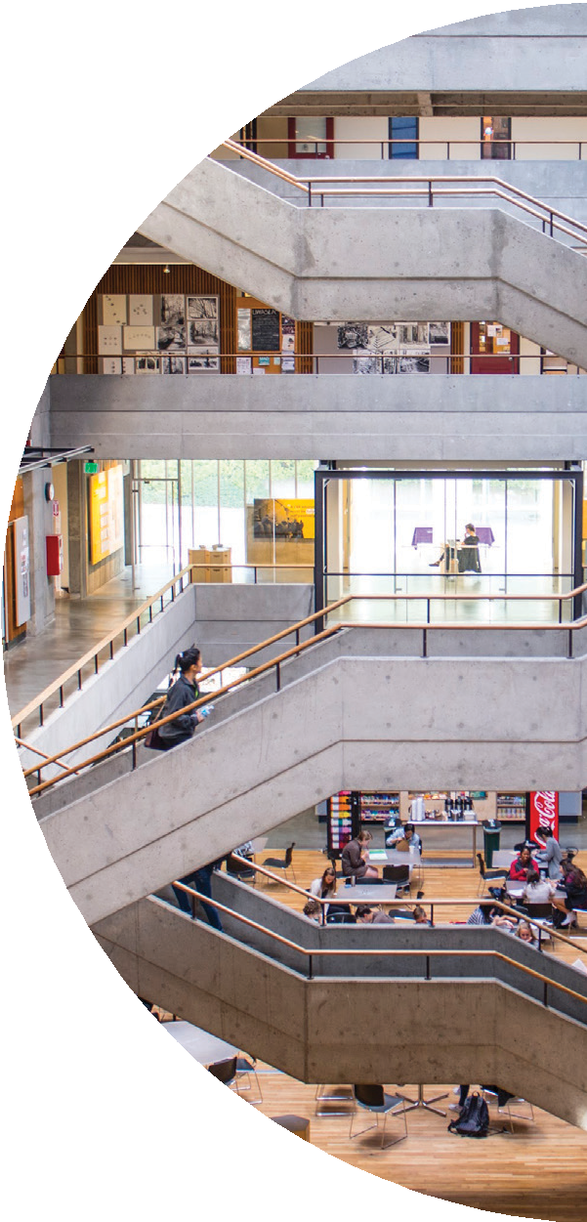
On behalf of the College of Built Environments at the University of Washington, I am writing to express our sincere appreciation for your continued support and commitment to advancing excellence in
construction management and the built environments. Your generous investment in establishing the John E. Schaufelberger Endowed Professorship and the Built Environments (BE) Faculty Fellowship in Research Innovation have made a transformative impact on our faculty, students, and the broader academic and professional communities.

It is with great pride that I share updates on the outstanding faculty members who currently hold these prestigious positions:

Catherine De Almeida, PLA, ASLA, associate professor and recipient of the Built Environments (BE) Faculty Fellowship for Research Innovation, is
leading critical work at the intersection of landscape architecture, material reuse, and environmental justice. Her research and teaching emphasize regenerative design and circular material economies, engaging students in hands-on, community-based projects that address pressing ecological and social challenges.

Amos Darko, Ph.D., M.ASCE, assistant professor and holder of the John
E. Schaufelberger Endowed Professorship in Construction Management, continues to advance impactful research in sustainable construction, modular building systems, and digital innovation. His scholarship is widely recognized, and his student-centered teaching approach is helping shape the next generation of construction leaders.

Carrie Sturts Dossick, Ph.D., P.E., professor, associate dean for research and recipient of the John E. Schaufelberger Endowed Professorship in







Construction Management, is a recognized leader whose contributions have significantly shaped the Department of Construction Management and the broader College community. Her leadership in integrated project delivery, digital collaboration, and construction education has elevated the learning experience for our students and strengthened our ties with industry partners.

Your support has empowered these faculty members to pursue innovative research, mentor students, and contribute meaningfully to the evolution
of our field. The impact of your generosity extends far beyond our campus, influencing the built environment and construction management industries at large.

Enclosed, you will find letters from each of the faculty members, offering a closer look at their recent accomplishments and the impact of your support.

Thank you once again for your vision and generosity. We are deeply grateful for your continued partnership and look forward to sharing more of our collective successes in the years to come.

Warm regards,

Ken P. Yocom, Ph.D.
Professor
John and Rosalind Jacobi Family Endowed Dean UW College of Built Environments

Catherine De Almeida, PLA, ASLA

Dear John,

I am writing with deep gratitude to thank you for your generous support through the Built Environments (BE) Faculty Fellowship for Research Innovation. I am truly honored to be the inaugural recipient for this Fellowship, which was made possible because of your foresight and generosity. As shared in the announcement nearly one year ago, the caliper of applicants for the Glazer Endowed Professorship was exceptionally high, and the decision to extend support to three faculty members through additional donor contributions such as yours demonstrates a remarkable commitment to nurturing vital and timely research across the College of Built Environments, research that addresses urgent challenges facing our built environments.
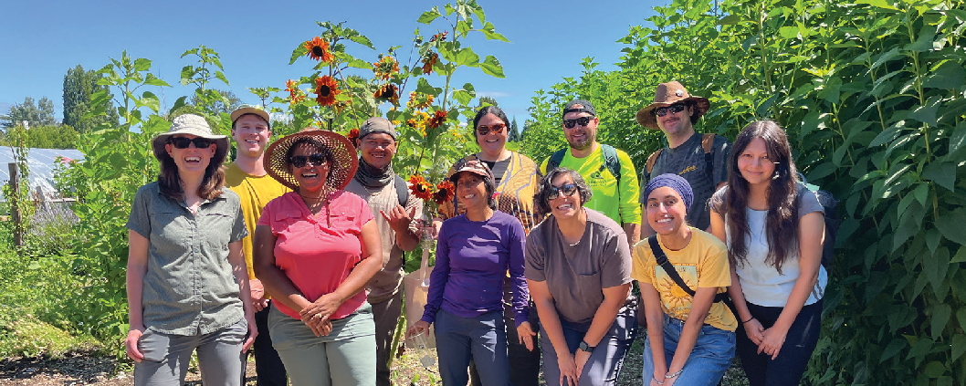
Image: Group photo of Catherine and her research team.

Your investment in this fellowship comes at a pivotal moment in my academic career and will have an enduring impact on my scholarship, teaching, and service. My research centers on waste as a critical—and often overlooked—lens through which to understand pressing social, environmental, and climate injustices and crises. Humanity now consumes natural resources 75% faster than they can be replenished, and the consequences of this extractive cycle are acutely felt by low-income and communities of color, particularly those located near waste infrastructure, industrial facilities, or contaminated sites. My work interrogates the

systems that produce waste—material, ecological, spatial, and social— and reframes waste as an abundant, if unevenly distributed, renewable resource. I argue that how we manage, design with, and relate to waste will determine our capacity for climate resilience and justice in the built environment.

The BE Faculty Fellowship for Research Innovation is directly supporting the development of my first book, Landscape Lifecycles: Repairing Waste
Relations for Climate Justice through Creative Reuse, Recovery, and Community- Centered Design. Scheduled for development during my Winter–Spring 2026 sabbatical, this monograph synthesizes over a decade of applied research, fieldwork, and community-engaged design focused on waste landscapes and regenerative practices. The book will integrate site-based case studies from across the U.S. and internationally; essays on tensions that shape waste relations (such as individualism vs. collectivism, or top-down vs. bottom-up governance); and visual frameworks that communicate circular and just approaches to material reuse, ecological repair, and systemic transformation.

Funding from this fellowship is enabling me to travel to and document key case studies, collaborate with student researchers on data visualization and lifecycle diagrams, and dedicate time to writing and synthesizing a body of work that has evolved through multiple research projects, grants, and design studios. It is also providing crucial flexibility: supporting field- based documentation, community interviews, publication development, and the production of graphics and digital tools that will help extend the reach of this work to broader audiences—including municipal leaders, grassroots organizers, and design practitioners.

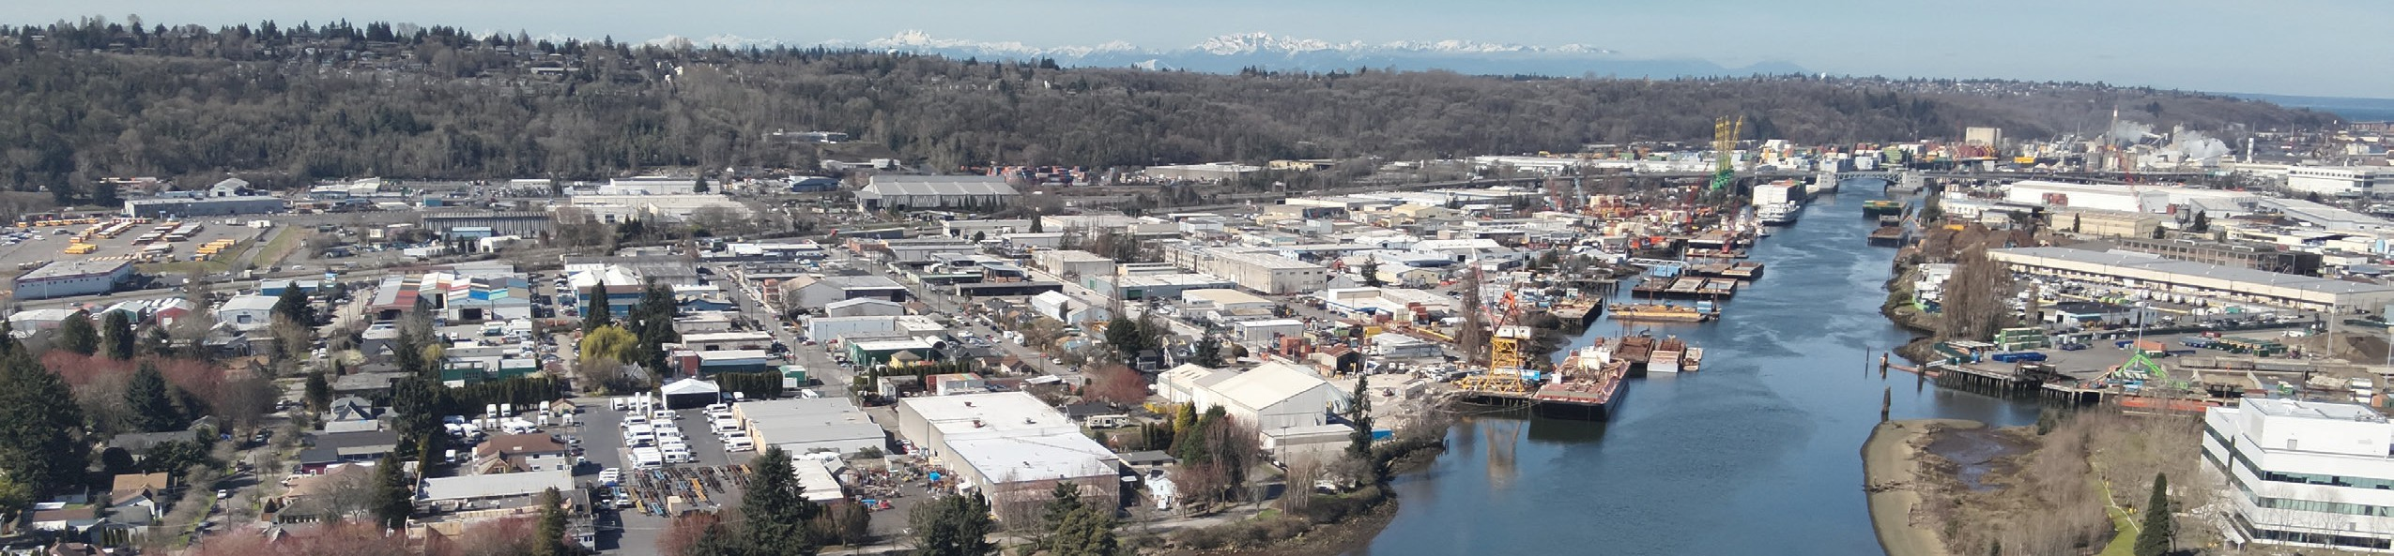
The fellowship not only amplifies my individual research, but also strengthens my ability to mentor students, support community-led initiatives, and contribute to the College of Built Environments’ mission of shaping equitable, sustainable, and resilient futures. In the past year

Image: Drone photo of the Duwamish Valley.


alone, I have advised award-winning student work focused on waste and environmental justice in the Duwamish Valley, collaborated with community partners to envision alternatives to extractive development, and contributed to national conversations on just transitions through public lectures and interdisciplinary grant projects.

I am proud to share that this work builds on over $1.5 million in grant funding I have received to advance regenerative economies, waste justice, and collaborative design with historically overburdened communities.
These projects—supported by the EPA, EarthLab, and Urban@UW—have been co-developed with community organizations such as the Duwamish River Community Coalition and the Duwamish Valley Sustainability Association. They exemplify my commitment to research that is both rigorous and reparative, aligned with the College’s goals of equity, sustainability, and public impact.

What this fellowship provides is more than financial support; it is an affirmation of work that often challenges conventional approaches and metrics of scholarly success. It provides the time, space, and resources needed to carry forward ideas that respond to urgent societal challenges and to do so in ways that are collaborative, grounded, and transformative. I am deeply grateful for your vision and generosity in supporting this kind of work at the College of Built Environments, University of Washington.

In the coming year, I look forward to sharing updates on the book’s progress, as well as continued opportunities to showcase the ways this fellowship is catalyzing long-term impact—on my scholarship, my students, and the communities I partner with. Thank you again for believing in this work and in the importance of innovation that bridges research, teaching, and public good.

With gratitude and appreciation,


Catherine De Almeida, PLA, ASLA
Associate Professor
John E. Schaufelberger Endowed Professor Department of Landscape Architecture UW College of Built Environments

Amos Darko, Ph.D., M.ASCE

Dear John,

On behalf of the entire Department of Construction Management at the University of Washington, I am writing to extend our deepest gratitude for your support of the John E. Schaufelberger Endowed Professorship. Your generous endowment plays a central role in advancing the mission and work of our department, specifically in the integration of faculty research into teaching to enhance the quality of instruction provided to students.

I’m excited to share with you that in fall 2024, I was appointed to hold the John E. Schaufelberger Endowed Professorship in Construction Management. I look forward to building upon the successes made possible through support of the endowment while forging a new path forward.

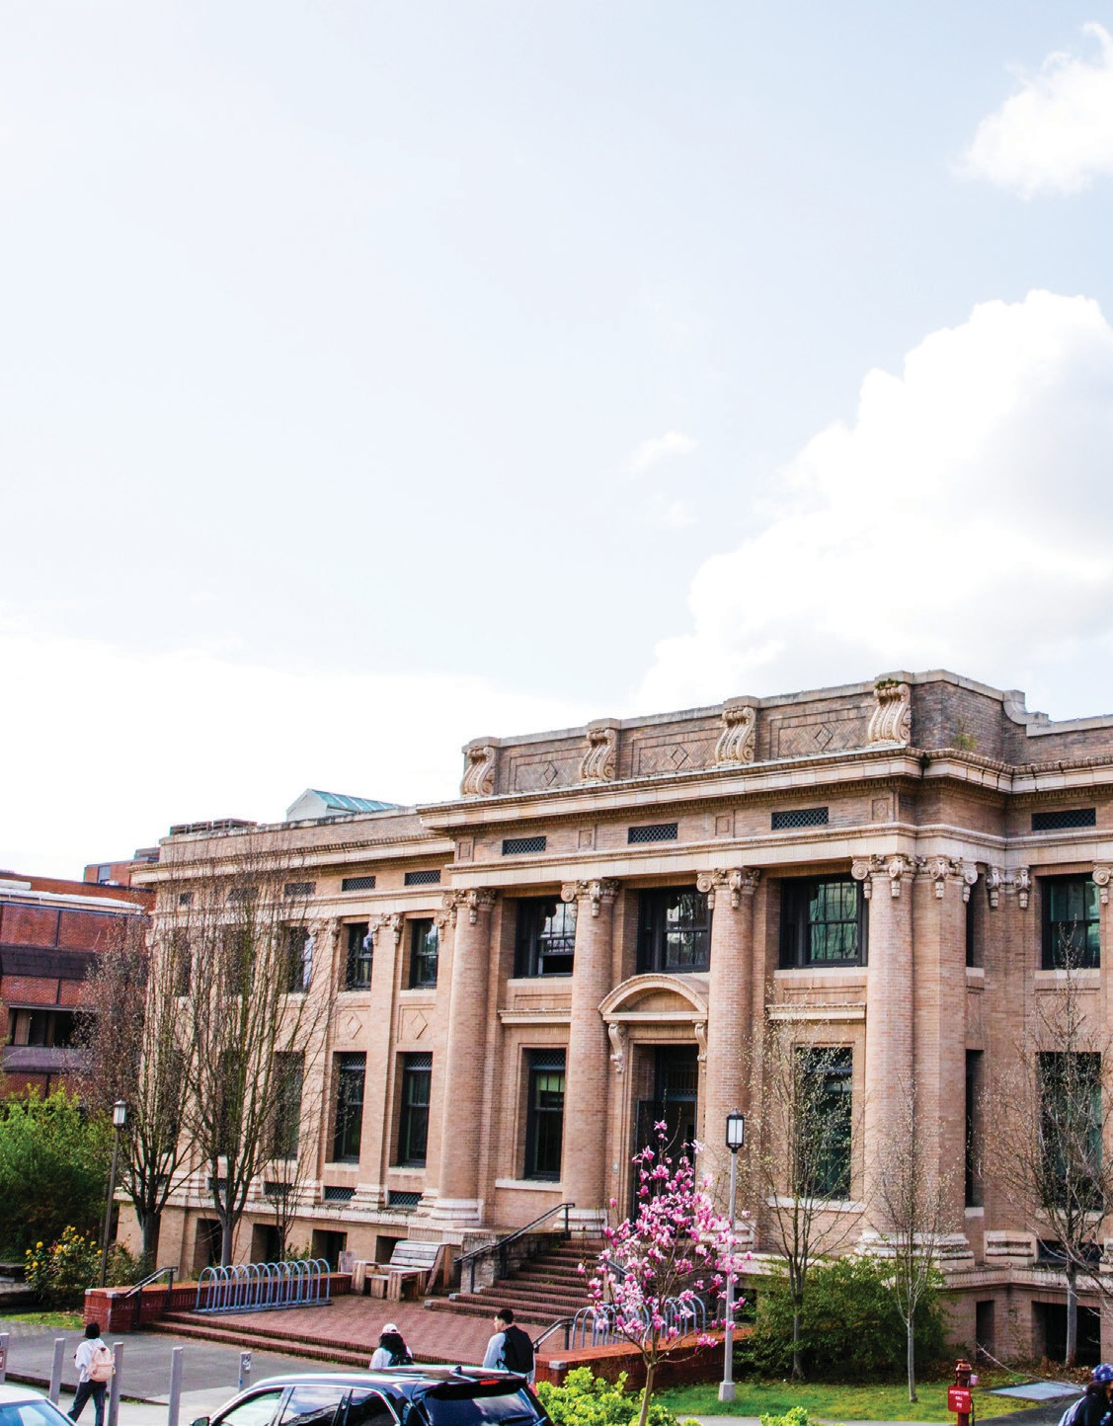
Where We Have Been

Since joining the Department in December 2023, I have been working hard to establish the Green Building Education and Research (GBER) Lab and redesign the CM 335 Sustainable Construction class. I am interested in research applications that contribute to making buildings work and perform better
to improve the health of occupants, the environment, and the economy. Support of the John E. Schaufelberger Endowed Professorship
in Construction Management has enhanced our research capabilities to allow students to become involved in my work. The funds have supported three students working with me to study and enhance building performance.

The Architecture Hall at the University of Washington was constructed between 1907 and 1909 and has undergone several

renovations, with the last renovation performed in 2006-2007, almost two decades ago, to improve its interiors and exterior brick walls. Yet, the building remains one of the university’s most ‘problematic’, with broken envelopes, faculty, students, and staff experiencing thermal discomfort and air quality problems, and inefficient energy use. With your generous
endowment, students have been involved in a new research project aimed at understanding and improving the performance of the Architecture Hall for the health benefit of faculty, students, and staff. Working closely with UW Facilities, we have been monitoring air quality in the building since October 2024. We have also remodeled the entire Architecture Hall through a Scan-to-BIM (building information modeling) exercise and conducted energy analysis, evaluating both actual and simulated energy use data
for a period of 1.3 years ( January 2024 – March 2025). We are analyzing several existing, outdated documentations about the building and finding improvement solutions.
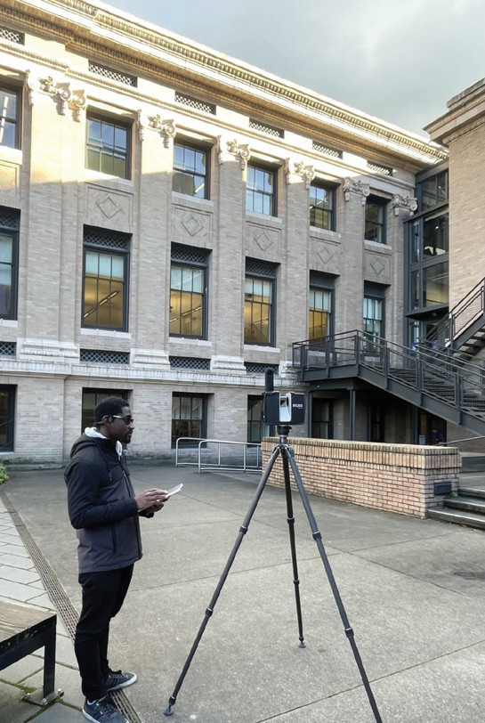
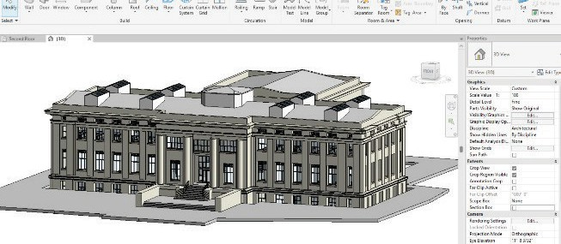
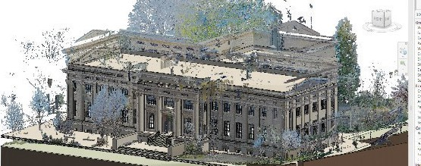
Images: (Left) Student performing laser scanning of Architecture Hall. (Right) Scan-to-BIM modeling of Architecture Hall.

This support has allowed students to gain essential research experience and skills in emerging areas, including laser scanning, BIM modeling, and energy simulation. It has also allowed us to augment the quality
of teaching and learning experience by exposing students to the latest research findings and developments from a building they know and study in, keeping their education current. I have integrated this work into CM 335 (Sustainable Construction) and CM 535 (Research Methods in Construction) classes. In addition, in June, I presented this work in ARCH 592 (Research

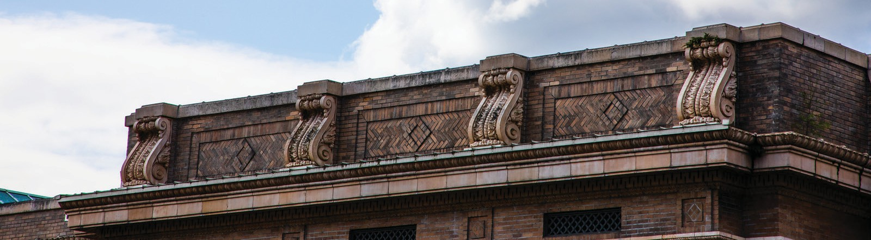
Methods) class as a guest speaker, which indicates that both Construction Management and Architecture students are benefiting from this support. This work has also led to a full international conference paper titled “Scan- to-BIM Process Framework for Energy Retrofits of Academic Facilities,” which I will be presenting at the 1st Global Forum for Sustainable Built Environment Research Conference (SURE-Built 2025) this September. This support is gratefully acknowledged in this paper. I have also been invited to deliver a keynote speech at this conference due to this and other innovative work by my research lab.

Where We Are Going

I am thrilled to continue the explorations in building performance and sustainability in the coming academic year 2025-2026 as holder of the John
E. Schaufelberger Endowed Professorship and look forward to collaborating with students, industry professionals, and academics in pushing the boundaries of building performance.

For academic year 2025-2026 and the foreseeable future, I have chosen to continue to establish the Green Building Education and Research (GBER) Lab with an online presence (website) and leverage funding from the
John E. Schaufelberger Endowed Professorship to support more students in conducting innovative research and integrating that research into
teaching. I will also continue to disseminate the research through impactful conference presentations and journal and other publications. I will continue pursing the primary goals of the Architecture Hall project of evaluating the energy and carbon performance, air quality, and occupant comfort of the building and supporting future upgrades that balance efficiency, comfort, and preservation. The next stage of work involves calibration of our
energy models, carbon assessments, digital twin development, and retrofit assessments.


I aspire to create strong connections with industry partners and communities in the greater Seattle area for potential research partnerships and to gain insights into how the Department can best equip our students to excel in their future careers. I also aspire to secure grants to expand our research and support for students. I will leverage this support to develop collaborative and pilot projects that enhance our capabilities to compete for large research grants.

Thank you!

Your generous philanthropic investment to establish the John E. Schaufelberger Endowed Professorship in Construction Management has opened the door to numerous exciting opportunities for our Department, directly benefiting our students. Thanks to the support of this fund, we can enhance the student learning experience and provide them with invaluable exposure, experience, and resources. Once again, thank you for your generosity and for supporting our mission. We deeply appreciate your ongoing partnership and look forward to sharing more of our accomplishments with you in the future.

Warm regards,


Amos Darko, Ph.D., M.ASCE
Assistant Professor
John E. Schaufelberger Endowed Professor Department of Construction Management UW College of Built Environments

Carrie Sturts Dossick, Ph.D., P.E.,

Dear John,

It has been such an honor for me to receive the John E. Schaufelberger Endowed Professorship. While I am serving as the Associate Dean for Research, I continue to be active in research as well, with several funded projects and several graduate students.

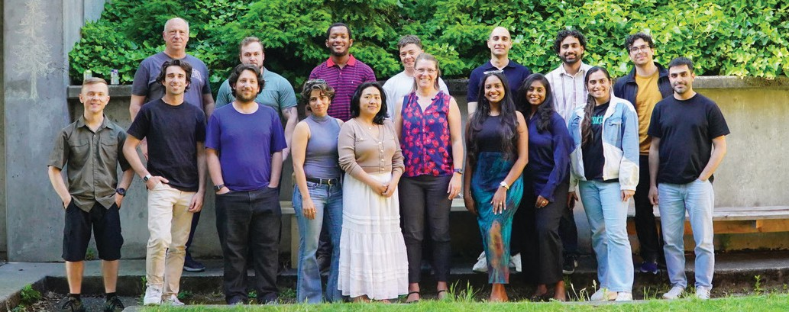
First, I am excited to announce that the National BIM Standard V4 was published last year. It has been a long time in the making. I co-chaired the planning committee with John Messner, and we steered the process from ideation through publication. I am very proud of the work, and I see the support of this professorship supporting further research into the implementation of the standard at both the federal and state levels. This will help owners establish BIM requirements for project delivery that not only will support design and construction, but operations of our build environments.

Image: Group photo of Carrie with graduate students.

Second, I have been working in partnership with the Mechanical Contractors Association (MCA), the Sheet Metal Contractors (SMACNA), and the National Electrical Contractors Association (NECA) and their





foundations on a project to develop national metrics for VDC time. We have been defining VDC coordination activities and working with companies to pilot data collection efforts. This led us to also explore the definitions of roles and responsibilities across the sector, as well as levels of automation in construction. We are in the final stages of the project and will report out to the foundations in July.

Third, we are working with the Pankow Foundation to develop Owner Readiness Assessment tools for owners to assess the capabilities and competencies the owner organization needs for successful project management. We are getting into the details of progressive design build as well as more established methods of fixed price design build delivery.
Fourth, I have also been working with Bart Treece at the Mobility Innovation Center and faculty from CEE on the I-90 Digital Twin project.
It is a really interesting project to build a prototype of a Digital Twin for structural monitoring of the bridge. We now have equipment on the bridge, and it is getting more attention and interest with a new proposal to Sound Transit.

I am deeply appreciative of the support provided by the Schaufelberger Endowed Professorship. This funding enables me to offer research assistantships and travel support to students in my lab, empowering them to conduct meaningful research and share their findings at academic conferences. This generous support significantly enhances and extends the impact of our work.

Thank you for your generous support of the Department of Construction Management, and of the UW College of Built Environments.

With deep gratitude,


Dr. Carrie Sturts Dossick, P.E.
Professor and Associate Dean for Research Professor of Construction Management John E. Schaufelberger Endowed Professor Department of Construction Management UW College of Built Environments

